Applicants: Bannari Amman Institute of Technology Total No. of sheets: 02
Sheet No.: 01 of 02

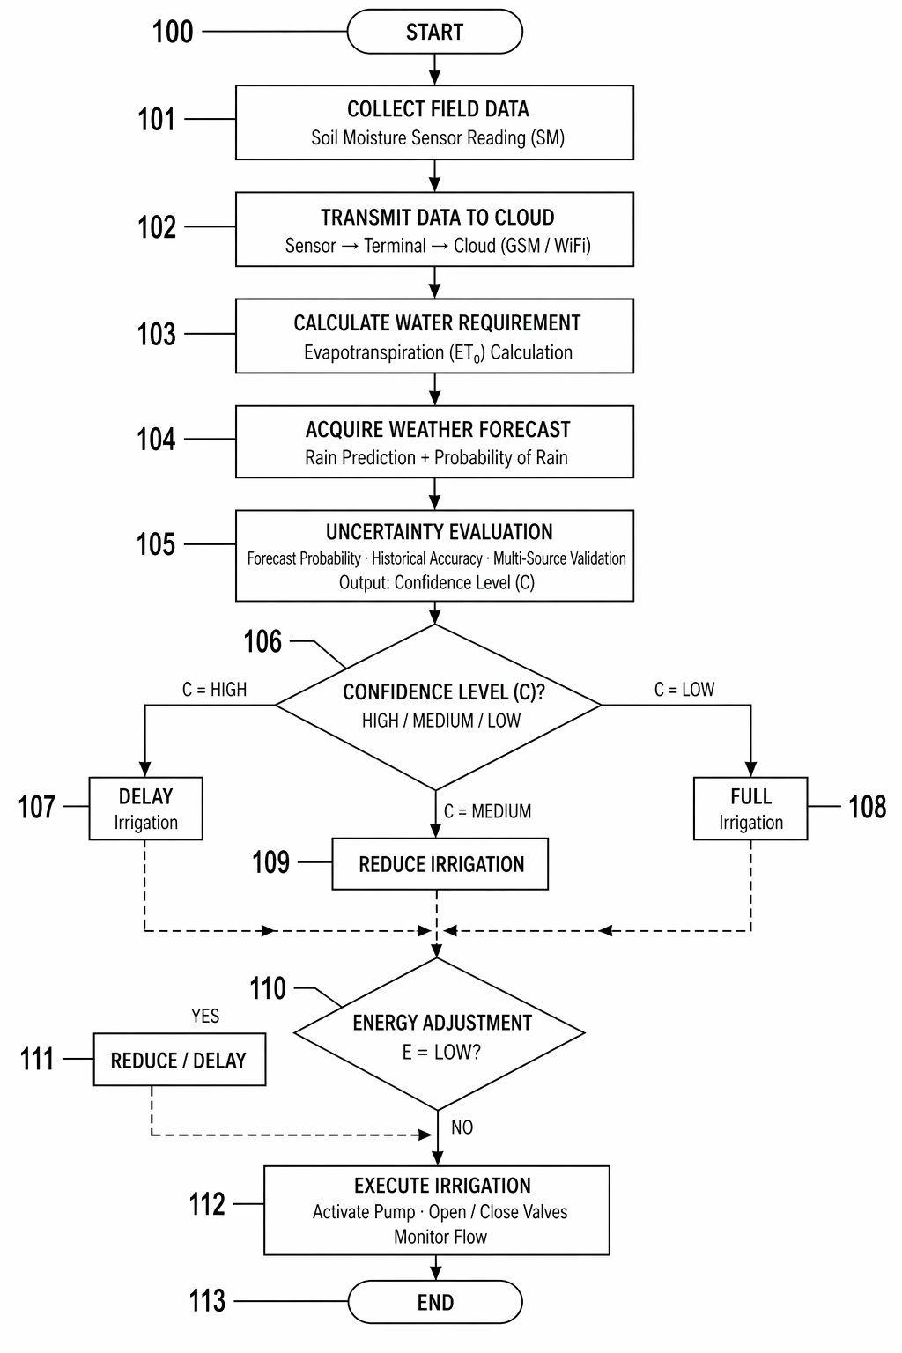
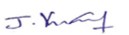
Vinoth Kumar J
Patent Agent (IN/PA 6111)
Agent for the Applicant

Applicants: Bannari Amman Institute of Technology Total No. of sheets: 02
Sheet No.: 02 of 02

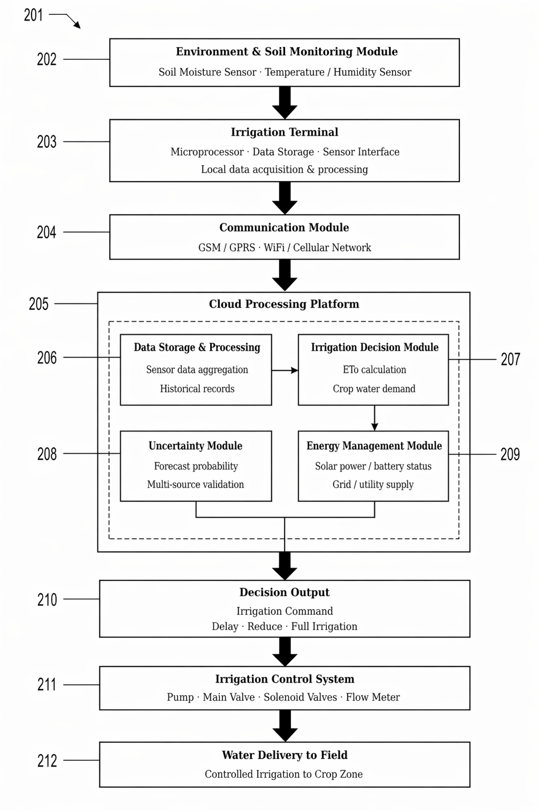

Vinoth Kumar J
Patent Agent (IN/PA 6111)
Agent for the Applicant

